**Requirements Analysis Document**

**For**

**Community Connect (Group 3)**

**Group Members:**

|  |  |  |
| --- | --- | --- |
| **Surname** | **Names** | **Student No** |
| HOMU | NHLAWULEKO ORIEL | 201911052 |
| MASEKO | VELAPHI SILINDILE | 202036211 |
| MOKOELE | MASHAO ANDRE | 201951302 |
| NALEDZANI | MUTSHUTSHU THABELO | 201817016 |
| RAMONTSHA | MAKGALANE INNOCENT | 202000982 |
| MATSHIPA | EDWIN | 201914329 |
| SEKOKOTLA | KAGISO PERCY | 201825048 |

Version 1.0

17 August 2023

**Requirements Analysis Document**

**Purpose:**

The introduction section of the RAD provides a succinct overview of the "Community Connect" platform, its purpose, and the driving factors behind its development. This section aims to set the context for the project and establish a foundation for the ensuing discussions. Key components of the introduction include:

**Audience**

1. **Customer:** The primary recipient of the RAD is the customer, the entity that has initiated the development of the "Community Connect" platform. The RAD serves as a critical communication tool to ensure that the customer's vision and expectations are accurately captured and translated into a functional system.
2. **Users:** The RAD addresses the needs and expectations of the end-users who will interact with the "Community Connect" platform. By detailing the functional and nonfunctional requirements, the RAD aims to create a system that aligns with users' preferences and enables a seamless and engaging experience.
3. **Project Management:** The project management team relies on the RAD to establish a clear and structured framework for project planning, resource allocation, and progress tracking. It provides an understanding of the project's scope, objectives, and the technical intricacies involved, aiding in effective decision-making.
4. **System Analysts:** The developers who participate in requirements elicitation and analysis form an essential audience for the RAD. They extract and interpret user needs from the document to design the underlying system architecture and functionality, ensuring that the final product aligns with stakeholders' expectations.
5. **System Designers:** The RAD is crucial for system designers who focus on creating detailed system models, interfaces, and user experiences. By referencing the functional and nonfunctional requirements outlined in the RAD, system designers can craft a comprehensive design that fulfills user needs.

**Introduction**

* 1. Purpose of the System:

The purpose of this section is to elucidate the overarching aim of the "Community Connect" system. The system, known as "Community Connect," has been conceptualized with a paramount goal: to establish a dynamic digital platform that seamlessly facilitates communication, interaction, and collaboration among the diverse members of a community. This platform serves as a virtual nexus, bridging geographical gaps and fostering a sense of togetherness among community members.

At its core, "Community Connect" aspires to transcend the limitations of traditional communication channels, offering an innovative solution that empowers individuals to engage, share ideas, organize events, and respond swiftly to emergent needs. By harnessing the capabilities of modern technology, the platform envisions a heightened level of connectivity that transcends time zones and enriches the community experience.

Crucially, this section functions as a foundational understanding between the customer and the developer. The document itself assumes the role of an agreement, one that articulates the aspirations of the community and translates them into a tangible blueprint for development. As such, this section sets the stage for the subsequent exploration of the system's intricacies and the delineation of its comprehensive requirements.

* 1. Scope of the System:

This section delineates the extensive scope within which the "Community Connect" system will operate. The platform's scope is comprehensive and dynamic, encompassing a range of interconnected functionalities designed to enhance community interaction and engagement. "Community Connect" is envisioned as a multifaceted solution that empowers community members to effectively communicate, collaborate, and respond to varying needs.

The scope of the system is structured around several core functionalities:

1. **Event Management**

* "Community Connect" will offer a sophisticated event management feature. This encompasses the creation, organization, and coordination of community events. Users will have the ability to create event listings, share event details, and manage RSVPs. Event organizers, in particular, will benefit from tools that streamline event planning and administration.

1. **Emergency Alerts**

* The platform will feature a robust Emergency Alert System that ensures real-time dissemination of critical information to all community members. Swift alert delivery during emergencies is paramount to prompt community response and support. This functionality serves as a lifeline, facilitating immediate communication and coordination in times of urgency.

1. **User Profiles**

* "Community Connect" will provide user profile functionality, enabling members to establish personalized profiles that showcase their interests, affiliations, and contributions within the community. This feature fosters a sense of identity and belonging, strengthening connections among community members.

1. **Donation Processing**

* The platform will facilitate secure and seamless donation processing. Users will be able to contribute funds to community initiatives and causes through a trusted and efficient payment gateway. This functionality promotes philanthropy and allows the community to support various projects and endeavors.

1. **Accessibility through Mobile**

* "Community Connect" will be accessible through mobile platforms, specifically on Android devices. This dual accessibility ensures that community members can engage with the platform using their preferred device, enhancing convenience and inclusivity.
* In essence, the scope of the "Community Connect" system encapsulates an array of capabilities that converge to cultivate a thriving and interconnected community ecosystem. By offering functionalities that span event management, emergency communication, user profiles, and secure donation processing, the platform aims to empower users and nurture a sense of unity, engagement, and shared purpose.
  1. Objectives and Success Criteria of the Project

1. **Improve Community Engagement**

The primary objective of the "Community Connect" project is to foster a vibrant and engaged community by providing a seamless digital platform for communication and interaction. This entails facilitating meaningful connections, enabling members to share experiences and insights, and promoting collaboration on community initiatives.

1. **Streamline Event Organization**

An essential goal of the project is to streamline event management within the community. "Community Connect" seeks to simplify the process of organizing, promoting, and participating in events. By offering robust event management tools, the platform aims to enhance the efficiency and effectiveness of community events.

1. **Enable Efficient Emergency Alert Dissemination**

A critical aspect of the project's vision is the establishment of a reliable Emergency Alert System. This system will enable swift and accurate dissemination of emergency information to community members. The platform's objective is to empower community members to respond promptly and effectively to emergencies, thereby contributing to the safety and well-being of all.

1. **Success Criteria**

The success of the "Community Connect" project will be evaluated based on measurable and tangible criteria, reflecting the attainment of its objectives:

1. **User Adoption Rates**

The degree to which community members embrace and actively engage with the platform will serve as an indicator of success. Increased user adoption rates signify that the platform effectively resonates with users' needs and preferences.

1. **Event Participation**

The project's success will be reflected in elevated rates of community event participation. A higher number of organized and well-attended events underscore the platform's effectiveness in streamlining event management and fostering community involvement.

1. **Prompt Emergency Alert Responses**

The efficiency of the Emergency Alert System will be assessed by the speed and efficacy of community responses to emergency alerts. Swift and coordinated responses underscore the platform's impact on enhancing community safety and emergency preparedness.

In essence, this section serves as a compass that guides the "Community Connect" project toward its intended destination. The articulated objectives and corresponding success criteria provide a clear roadmap for development, ensuring that the project's impact is not only profound but also quantifiable.

* 1. Definitions, Acronyms, and Abbreviations

This section serves as a lexicon that establishes a shared understanding of key terminology, acronyms, and abbreviations within the context of the "Community Connect" project. By providing clear definitions, this section ensures that communication remains unambiguous and consistent throughout the document and the project.

**Key Terms**

**Community Connect:**

The digital platform under development, designed to facilitate communication, event management, emergency alerts, and community interaction.

**Event Management:**

The process of planning, organizing, and coordinating community events through the "Community Connect" platform.

**Emergency Alert System:**

The real-time notification mechanism within the platform for promptly disseminating critical information to community members during emergencies.

**User Profiles:**

Personalized accounts created by community members to showcase their affiliations, interests, and contributions within the platform.

**Donation Processing:**

The secure mechanism for community members to contribute funds to community initiatives and causes.

**Acronyms**

RAD : Requirements Analysis Document

API : Application Programming Interface

SDK : Software Development Kit

IDE : Integrated Development Environment

PCI DSS **:**Payment Card Industry Data Security Standard Abbreviations

* 1. References

1. Wiegers, K., & Beatty, J. (2013). Software Requirements (3rd ed.). Microsoft Press. ISBN: 978-0735679665.
2. Pohl, K., & Rupp, C. (2011). Requirements Engineering: Fundamentals, Principles, and Techniques. Springer. ISBN: 978-3642155657.
3. Jackson, M. (1995). Software Requirements and Specifications: A Lexicon of Practice, Principles, and Prejudices. Addison-Wesley Professional. ISBN: 978-0321104191.
4. van Lamsweerde, A. (2009). Requirements Engineering: From System Goals to UML Models to Software Specifications. Wiley. ISBN: 978-0470847475.
5. Cockburn, A. (2000). Writing Effective Use Cases. Addison-Wesley Professional. ISBN: 978-0201702255.
6. Robertson, S., & Robertson, J. (2012). Mastering the Requirements Process: Getting Requirements Right. Addison-Wesley Professional. ISBN: 978-0321815743.
   1. Overview
7. **Document Structure**

The RAD is structured to comprehensively capture the essence of the "Community Connect" project, presenting a holistic understanding of its objectives, functionalities, and requirements. The document is organized into distinct sections, each contributing to a nuanced and comprehensive depiction of the project.

1. **Sections and Topics**

* **Introduction**: This section provides a foundational context for the project, elucidating the purpose, scope, objectives, and references that underpin the "Community Connect" platform.
* **Current System:** The existing landscape of community interaction is outlined, highlighting the need for a digital solution.
* **Proposed System:** This section delves into the heart of the "Community Connect" platform, expounding on its functional and nonfunctional requirements, system models, and a comprehensive glossary.
* **Template:** The RAD's template is expounded upon, detailing its various sections and their significance.

1. **Navigational Roadmap**

The overview serves as a roadmap, guiding readers through the document's sequential progression. By briefly summarizing the focal points of each section, readers can swiftly locate and comprehend specific areas of interest. This overview ensures that readers grasp the purpose and structure of the RAD, setting the stage for an informed and engaged exploration of the ensuing content.

**2. Current system**

1. **Overview**

The current system revolves around traditional modes of community interaction, primarily rooted in physical gatherings, telephone conversations, and email exchanges. While these methods have facilitated communication to some extent, they exhibit inherent limitations that hinder seamless engagement and efficient coordination among community members.

1. **Functionality**
2. **Physical Meetings**

Community members predominantly rely on physical meetings and gatherings to communicate and collaborate. While these gatherings offer face-to-face interaction, they are constrained by logistical challenges, time limitations, and geographic boundaries. As a result, effective communication and engagement are often hindered, particularly for members who cannot attend due to various reasons.

1. **Telephone Communication**

Telephone communication has been a staple in community interaction, enabling direct conversations between individuals. However, this method lacks real-time group communication capabilities, making it less suitable for disseminating urgent information to a large audience swiftly.

1. **Email Correspondence**

Email communication has enabled asynchronous communication, allowing members to share information and updates. Yet, emails may get buried in overflowing inboxes, leading to delayed responses and potential loss of important messages. Moreover, email lacks the instantaneous nature required for timely communication during emergencies.

1. **Challenges and limitations**

The current system's limitations have become apparent in several areas:

1. **Lack of Timeliness:** Urgent information, such as event updates or emergency alerts, may not reach all community members promptly.
2. **Limited Participation:** Geographic constraints and logistical challenges may restrict participation in community events and initiatives.
3. **Communication Gaps:** The reliance on disjointed communication channels can lead to missed opportunities for collaboration and engagement.
4. **Transition to "Community Connect"**

While the current system has its merits, the "Community Connect" platform aims to overcome these limitations by introducing a digital ecosystem that transcends traditional boundaries. By leveraging modern technology, the platform seeks to streamline communication, empower community members, and provide efficient mechanisms for event management, emergency response, and collaboration.

3. **Proposed system**

The Proposed System section constitutes the heart of the RAD, encapsulating the meticulously derived requirements and the intricate analysis model that underpin the visionary Community Connect platform. This section illuminates the platform's multifaceted functionalities, culminating in a comprehensive blueprint for its development and realization.

* 1. Overview:

This section serves as an in-depth exploration of the envisioned "Community Connect" platform, expounding on its functional capabilities, nonfunctional attributes, and the underlying analysis models that define its architecture.

* 1. Functional requirements:

1. User Registration

* The platform shall provide a user registration form with fields for username, email address, password, and optional profile information (the moderator will register users).
* It shall validate the email address format and ensure it is unique in the system.
* The system shall generate a secure password hash for the user's password to store it securely.

1. User Authentication

* The platform shall offer a login form with fields for username/email and password.
* It shall authenticate users by verifying the provided credentials against stored account information.
* After successful authentication, the platform shall generate a session token for the user to maintain their login state.

1. Email Verification

* Upon successful registration, the system shall send a verification email to the user's provided email address.
* The email shall contain a link to verify the user's account, which, when clicked, confirms the email address in the system.

1. Forgot Password Functionality

* The platform shall provide a Forgot Password option on the login page.
* Users can reset their passwords by receiving a password reset link via email.
* Sessions shall be automatically terminated after a period of inactivity or upon user log out.

1. Event Creation

* The platform shall offer an event creation form with fields for event title, date, time, location, description, and category tags.
* Users should be able to create, edit, or cancel events they have created.

1. Event Categorization

* The platform shall categorize events based on predefined tags or user-specified tags for easier event discovery.

1. Event RSVP

* Users should be able to RSVP for events they plan to attend or indicate their interest in attending.
* The platform shall provide event reminders and notifications to users who have RSVP'd.

1. Emergency Alert Creation

* The platform shall provide a dedicated form for authorized users to create and submit emergency alerts.
* Alerts should include essential information, such as the type of emergency, location, and recommended actions.

1. Instant Alert Dissemination

* The platform shall ensure that emergency alerts are sent instantly to all community members through push notifications or other immediate means of communication.

1. Emergency Alert Visibility and Priority

* The platform shall display emergency alerts with high visibility and priority to ensure they capture users' immediate attention.

1. User Acknowledgment and Response

* Community members should be able to acknowledge and respond to emergency alerts to indicate their safety status or assistance needs.

1. Campaign Creation

* The platform shall offer a campaign creation form with fields for campaign title, description, target amount, and optional media content.
* Users should be able to add, edit, or delete campaigns they have created.

1. Donation Processing

* The platform shall provide a secure payment gateway to process donations from users.
* It should support multiple payment methods, such as credit cards, mobile wallets, or online banking.

1. Campaign Progress Updates

* The platform shall display real-time updates on the progress of fundraising campaigns, showing the current donation amount and the remaining target.

1. Donor Management and Information Security

* The system shall manage donor information securely and ensure compliance with data protection regulations.

1. Transparency in Fund Utilization

* The platform should provide mechanisms for campaign owners to communicate updates on how the raised funds are being used.

1. Campaign Creation

* The platform shall offer a campaign creation form with fields for campaign title, description, and optional media content.
* Users should be able to add, edit, or delete campaigns they have created.

1. Donation Processing

* The platform shall provide a secure payment gateway to process donations from users.
* It should support multiple payment methods, such as credit cards, mobile wallets, or online banking.

1. Campaign Progress Updates

* The platform shall display real-time updates on the progress of fundraising campaigns, showing the current donation amount and the remaining target.

1. Donor Management and Information Security

* The system shall manage donor information securely and ensure compliance with data protection regulations.

1. Transparency in Fund Utilization

* The platform should provide mechanisms for campaign owners to communicate updates on how the raised funds are being used.

3.3 Nonfunctional requirements

3.3.1 **Usability**

Usability stands as a cornerstone of the "Community Connect" platform, ensuring that users can intuitively navigate, comprehend, and engage with the system. The user interface will be designed to foster a seamless and enjoyable interaction, featuring clear navigation paths, intuitive layouts, and visually appealing design elements. The platform's usability will be validated through user testing and feedback, driving continuous enhancements to elevate the user experience.

3.3.2 **Reliability**

Reliability is paramount, especially concerning the Emergency Alert System. The system will be engineered with redundancy and failover mechanisms to ensure uninterrupted alert delivery during emergencies. Rigorous testing and quality assurance protocols will be employed to verify the system's reliability, aiming for a 99.9% uptime rate.

3.3.3 **Performance**

The "Community Connect" platform will exhibit optimal performance, catering to a substantial number of concurrent users without compromising responsiveness or efficiency. System performance metrics will be continuously monitored, and optimizations will be implemented to maintain seamless operation during peak usage periods.

3.3.4 **Supportability**

Supportability encompasses the platform's ability to be easily maintained, enhanced, and extended over time. The codebase will adhere to industry-standard coding practices and documentation standards, enabling efficient bug fixes, updates, and future enhancements. Detailed documentation and training resources will be available to aid developers and administrators in effectively managing the platform.

3.3.5 **Implementation**

The implementation aspect pertains to the process of translating design specifications into a functional system. Coding standards, version control, and development methodologies will be followed meticulously to ensure a structured and coherent implementation process. Comprehensive testing will be conducted at each development stage to detect and rectify any anomalies.

3.3.6 **Interface**

Interface design is crucial to providing a visually appealing and consistent user experience. The platform's user interfaces, mobile (Android), will adhere to established design guidelines, ensuring uniformity and ease of use across devices. Interfaces will be responsive, adapting seamlessly to different screen sizes and orientations.

3.3.7 **Packaging**

Packaging refers to the deployment and distribution of the platform. The packaging process will encompass packaging the application for Android platforms, ensuring smooth and error-free installation for end-users.

3.3.8 **Legal**

Legal requirements encompass adherence to pertinent laws and regulations governing data privacy, fundraising, and emergency alert systems. The platform will comply with all relevant legal mandates, safeguarding user data, ensuring secure payment processing, and facilitating transparent communication of terms and conditions.

**3.4 System models**

**3.4.1 Scenarios**

**User Scenario 1:** Community Member

User: A resident who resides in the community.

**Scenario:**

* The community member visits the "Community Connect Platform."
* The community member registers an account, and their verification is done by the chief or administrators.
* After email verification, the community member signs in using their email credentials.
* They complete their profile by adding interests and a profile picture.
* They explore the Skill Sharing Hub, Community Announcements, and use the Emergency Alert System as needed.
* The community member engages with the Secure Donation Platform, making donations, and participating in fundraising campaigns.
* They also use the Volunteer Matchmaking, Community Forums, User Recognition and Rewards, and Privacy and Security features.

**User Scenario 2:** Community Organization

User: An enthusiastic community member who represents a community organization.

**Scenario:**

* The user from a community organization logs in to the "Community Connect Platform."
* They post volunteer opportunities using the Volunteer Matchmaking feature.
* They use the Community Announcements feature to post events and inform the community.
* The user creates fundraising campaigns on the Secure Donation Platform, setting up campaign details.
* They receive donations through the Secure Donation Platform and manage fundraising campaigns.
* The user navigates to the event management section and uses the Create Fundraising Campaigns and Secure Payments features.
* They keep track of attendees for events and use the platform to engage with the community.

**User Scenario 3:** Moderator

User: A community member responsible for moderating the platform.

**Scenario:**

* The user with moderation responsibilities registers an account on the "Community Connect Platform."
* They assist in verifying user registrations for Community Members, Community Organizations, and other Moderators.
* The user moderates’ content on the Community Forums feature, resolving conflicts and providing user support.
* They also oversee fundraising campaigns on the Secure Donation Platform, ensuring proper functioning and resolving issues.
* The user actively participates in resolving conflicts related to fundraising campaigns and user interactions.

3.4.2 Use case model:

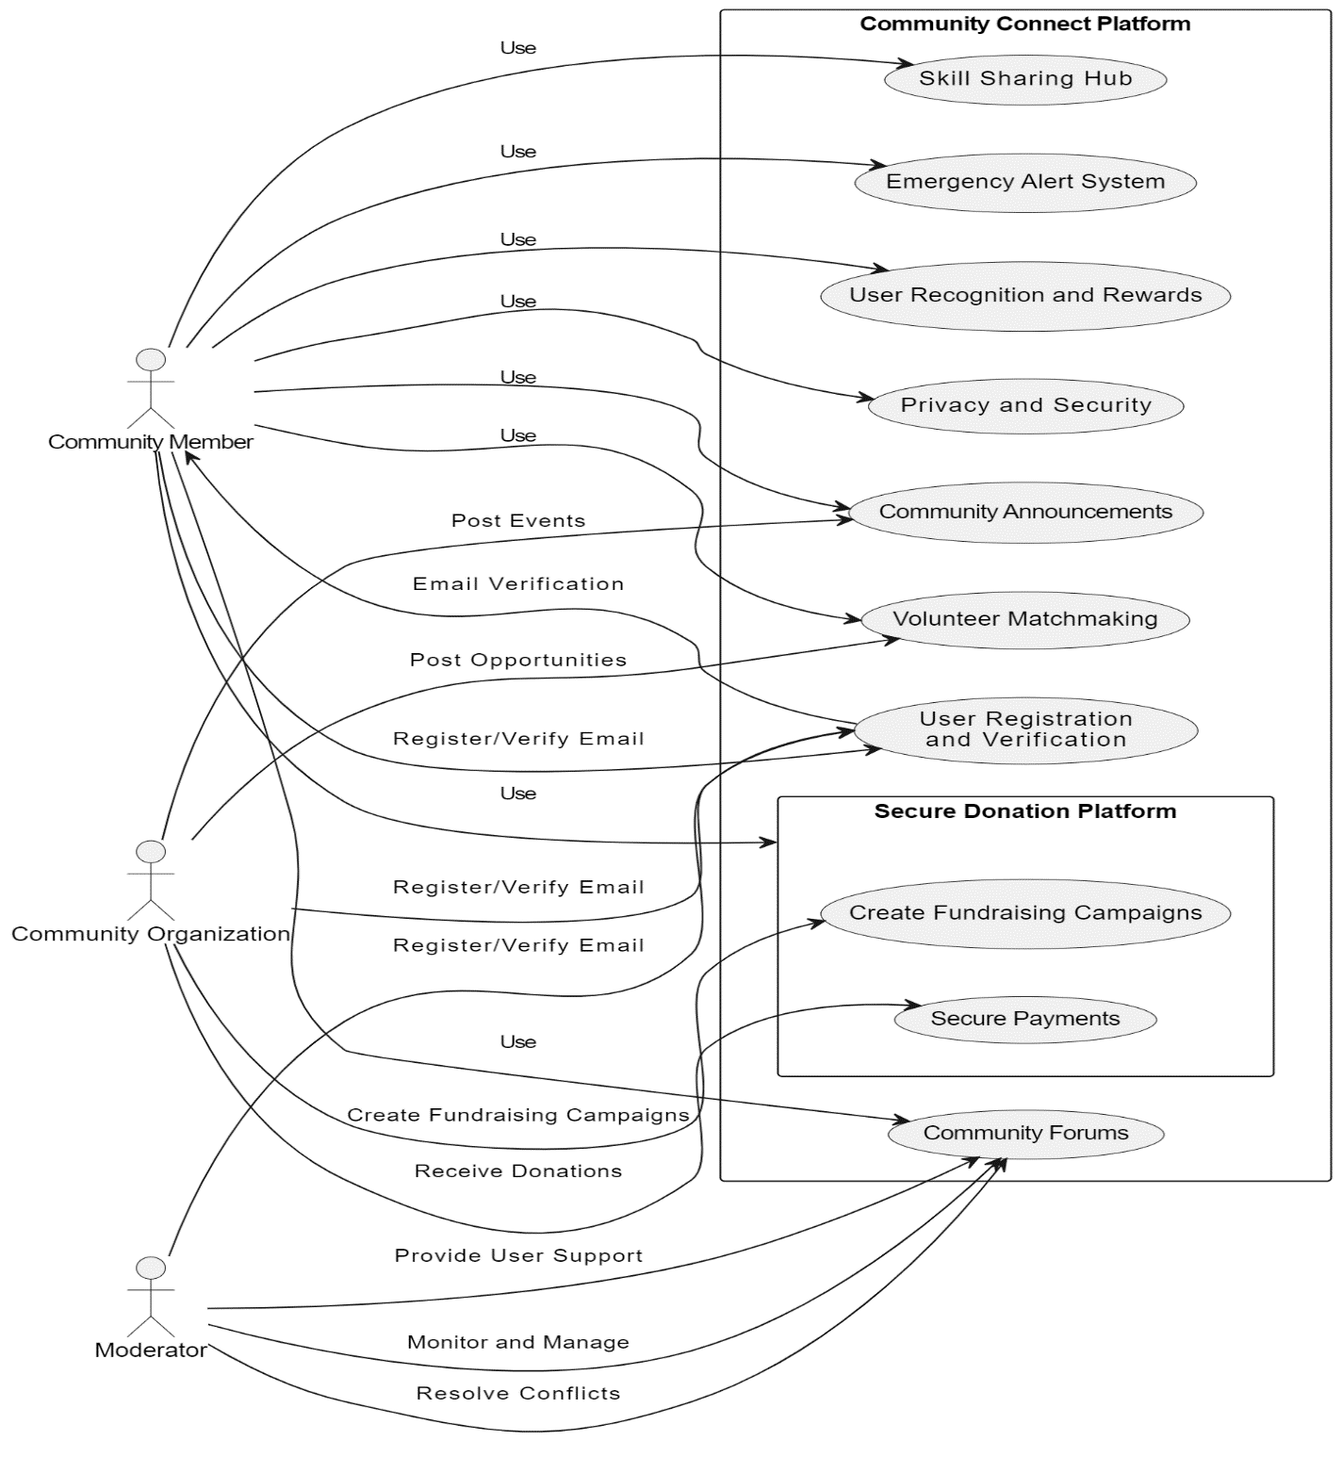

3.4.3 Analysis object model

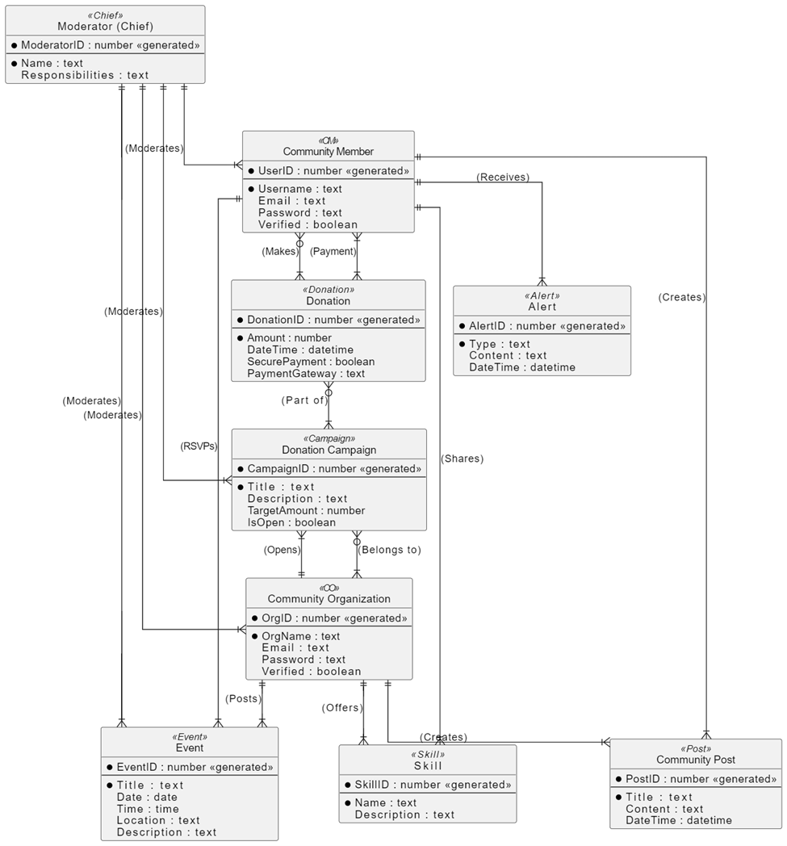

3.4.4 Dynamic model

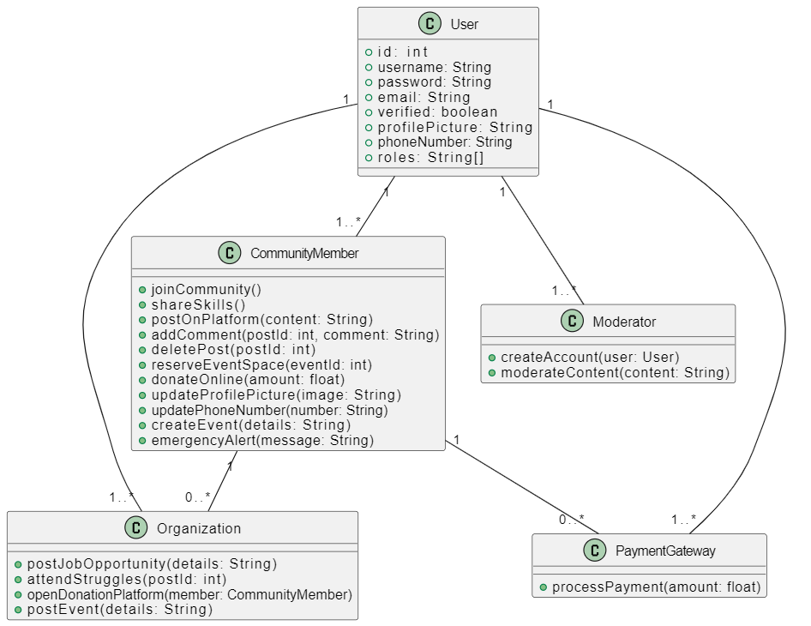

3.4.5 User interface

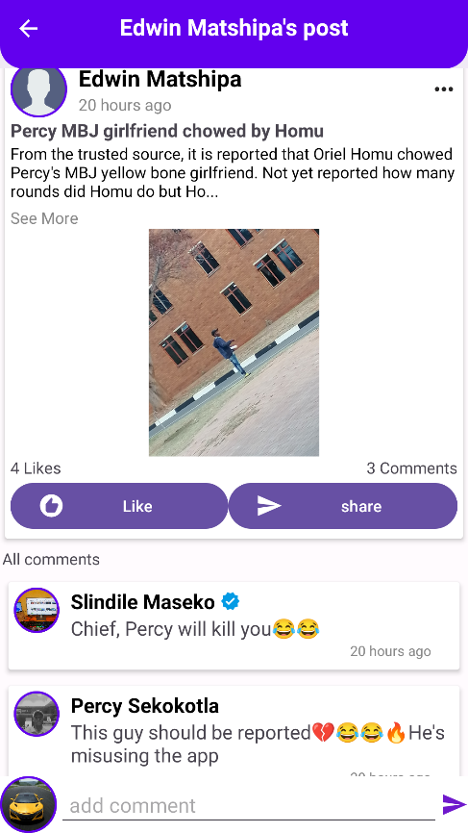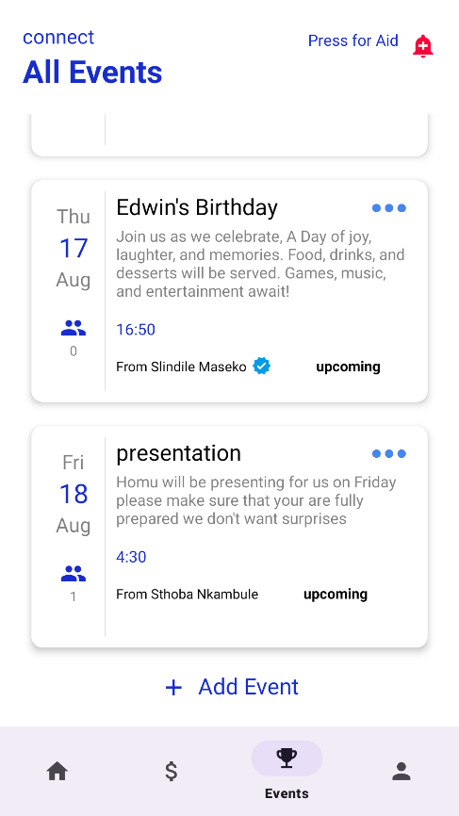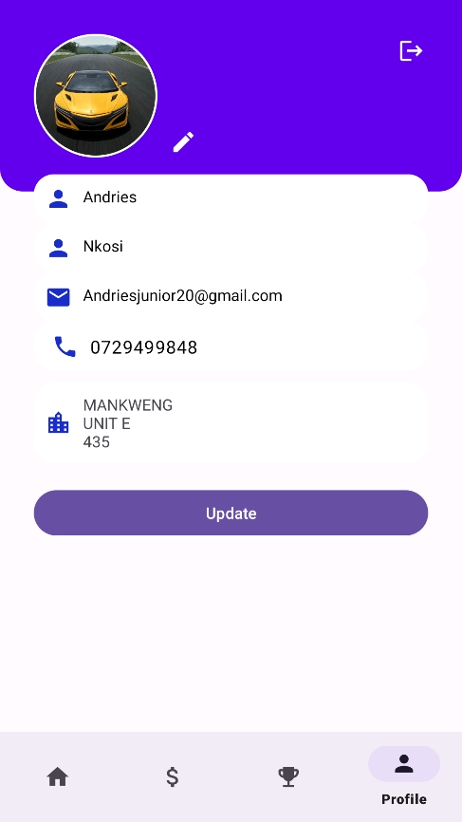

4. Conclusion

In summary, the Community Connect platform stands as an innovative solution poised to revolutionize community engagement and interaction. With a clear focus on addressing the limitations of traditional communication channels, the platform's many-sided functionalities promise to bridge geographical gaps and foster a sense of togetherness among community members.

By seamlessly integrating features like the Skill Sharing Hub, Community Announcements, Emergency Alert System and Secure Donation Platform. Community Connect envisions a comprehensive ecosystem that caters to diverse community needs. The many-sided outlined functional and non-functional requirements ensure usability, reliability, performance, and supportability, laying a strong foundation for its successful implementation.

User scenarios strongly illustrate the platform's real-world applications, from community members leveraging its capabilities to moderators ensuring a safe environment. Community Connect emerges not only as a digital tool but as a transformative force, enhancing community engagement, event coordination, and emergency response.

As development progresses guided by the Requirements Analysis Document, Community Connect has the potential to reshape community dynamics, foster collaboration, and amplify the collective impact of its users. The platform represents a testament to the power of technology in creating meaningful connections and empowering communities in an increasingly interconnected world.